Angle
# Source: AI Source: Provided by: [Data Path: Persons Table -> ID Column: 1, Name_En Column: Motasem Essam] -> From: [ChatGPT] on [7/25/2026]
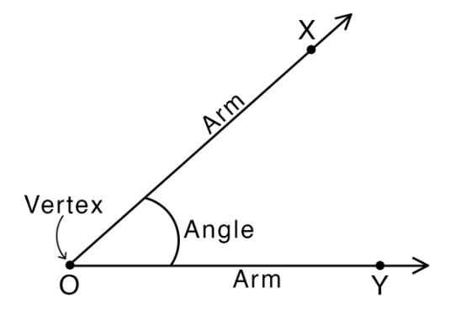
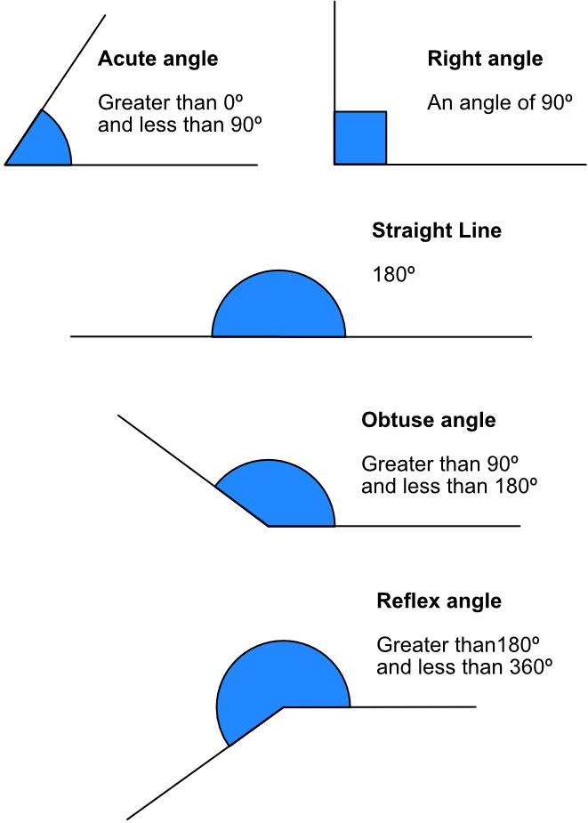
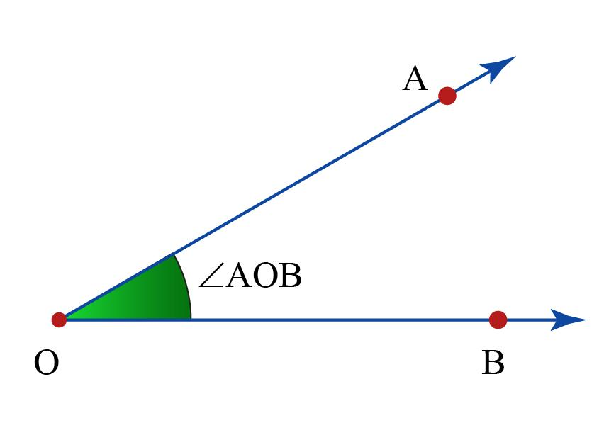
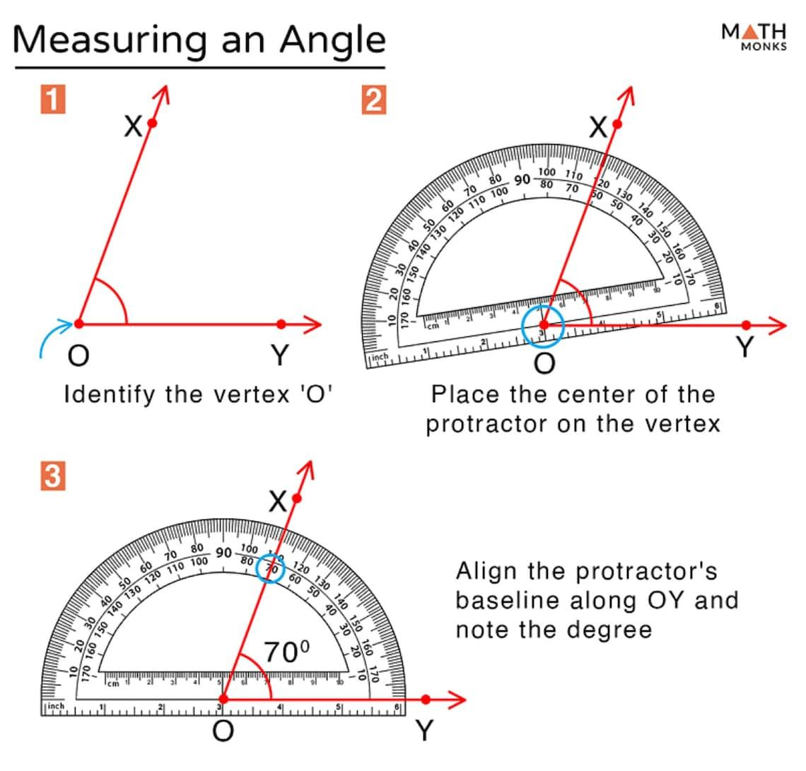
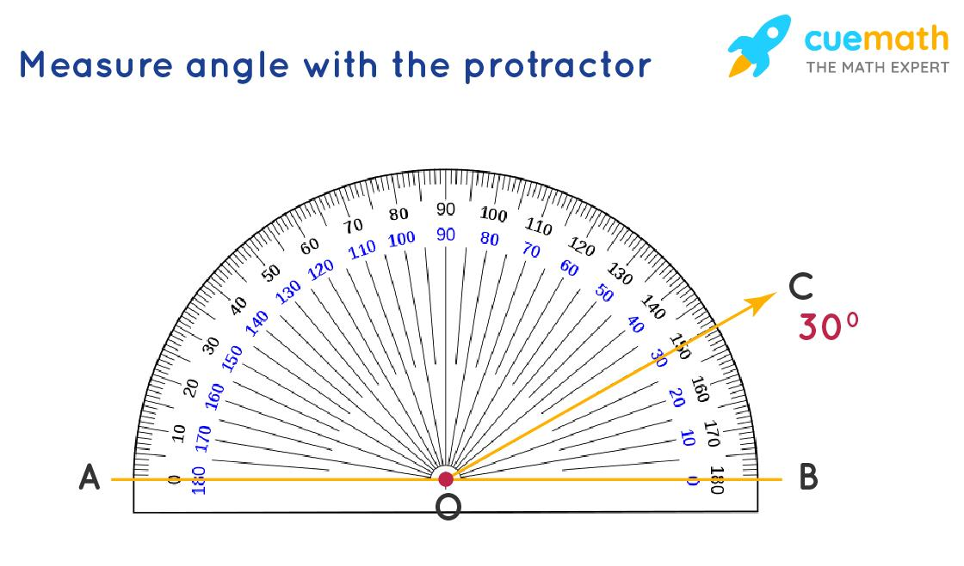

Definition
# Source: AI Source: Provided by: [Data Path: Persons Table -> ID Column: 1, Name_En Column: Motasem Essam] -> From: [ChatGPT] on [7/25/2026]
An Angle is a geometric figure formed by two rays that share a common endpoint. The common endpoint is called the vertex, and the two rays are called the sides or arms of the angle.
An angle represents the amount of rotation or opening between two directions.

Components of an Angle
# Source: AI Source: Provided by: [Data Path: Persons Table -> ID Column: 1, Name_En Column: Motasem Essam] -> From: [ChatGPT] on [7/25/2026]
Every angle consists of three main parts:

1. Vertex
# Source: AI Source: Provided by: [Data Path: Persons Table -> ID Column: 1, Name_En Column: Motasem Essam] -> From: [ChatGPT] on [7/25/2026]
The common endpoint where the two rays meet.
Example:
$$∠ABC$$
The middle letter B represents the vertex.

2. Sides (Rays)
# Source: AI Source: Provided by: [Data Path: Persons Table -> ID Column: 1, Name_En Column: Motasem Essam] -> From: [ChatGPT] on [7/25/2026]
The two rays that form the angle.
Example:
$$\overset{→}{BA}$$
and
$$\overset{→}{BC}$$

3. Interior Region
# Source: AI Source: Provided by: [Data Path: Persons Table -> ID Column: 1, Name_En Column: Motasem Essam] -> From: [ChatGPT] on [7/25/2026]
The space between the two rays that represents the angle measurement.

Illustration
# Source: AI Source: Provided by: [Data Path: Persons Table -> ID Column: 1, Name_En Column: Motasem Essam] -> From: [ChatGPT] on [7/25/2026]
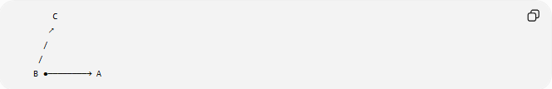
C
↗
/
/
B ●────────→ A
Angle:
$$∠ABC$$
Where:
- $B$ = Vertex
- $\overset{→}{BA}$ = One side
- $\overset{→}{BC}$ = Other side

Angle Notation
# Source: AI Source: Provided by: [Data Path: Persons Table -> ID Column: 1, Name_En Column: Motasem Essam] -> From: [ChatGPT] on [7/25/2026]
Angles can be written in several ways.

1. Three-Letter Notation
# Source: AI Source: Provided by: [Data Path: Persons Table -> ID Column: 1, Name_En Column: Motasem Essam] -> From: [ChatGPT] on [7/25/2026]
$$∠ABC$$
The middle letter is always the vertex.

2. One-Letter Notation
# Source: AI Source: Provided by: [Data Path: Persons Table -> ID Column: 1, Name_En Column: Motasem Essam] -> From: [ChatGPT] on [7/25/2026]
Used only when there is a single angle at the point.
Example:
$$∠B$$

3. Number or Symbol Notation
# Source: AI Source: Provided by: [Data Path: Persons Table -> ID Column: 1, Name_En Column: Motasem Essam] -> From: [ChatGPT] on [7/25/2026]
Example:
$$∠1$$
or
$$∠x$$

Angle Measurement
# Source: AI Source: Provided by: [Data Path: Persons Table -> ID Column: 1, Name_En Column: Motasem Essam] -> From: [ChatGPT] on [7/25/2026]
Angles are measured using:

Degrees
# Source: AI Source: Provided by: [Data Path: Persons Table -> ID Column: 1, Name_En Column: Motasem Essam] -> From: [ChatGPT] on [7/25/2026]
The most common unit:
$${}_{​}^{∘}​$$
Example:
$${45}^{∘}$$

Radians
# Source: AI Source: Provided by: [Data Path: Persons Table -> ID Column: 1, Name_En Column: Motasem Essam] -> From: [ChatGPT] on [7/25/2026]
The mathematical unit of angle measurement:
$$\text{radians}$$
Relationship:
$${180}^{∘}=π\text{ radians}$$

Types of Angles by Measurement

1. Zero Angle
# Source: AI Source: Provided by: [Data Path: Persons Table -> ID Column: 1, Name_En Column: Motasem Essam] -> From: [ChatGPT] on [7/25/2026]
$$θ=0^{∘}$$
The two rays overlap in the same direction.
────────●────────→

2. Acute Angle
# Source: AI Source: Provided by: [Data Path: Persons Table -> ID Column: 1, Name_En Column: Motasem Essam] -> From: [ChatGPT] on [7/25/2026]
$$0^{∘}<θ<{90}^{∘}$$
Smaller than a right angle.
Example:
$${45}^{∘}$$

3. Right Angle
# Source: AI Source: Provided by: [Data Path: Persons Table -> ID Column: 1, Name_En Column: Motasem Essam] -> From: [ChatGPT] on [7/25/2026]
$$θ={90}^{∘}$$
Forms a perfect corner.
Example:
$${90}^{∘}$$

4. Obtuse Angle
# Source: AI Source: Provided by: [Data Path: Persons Table -> ID Column: 1, Name_En Column: Motasem Essam] -> From: [ChatGPT] on [7/25/2026]
$${90}^{∘}<θ<{180}^{∘}$$
Larger than a right angle.
Example:
$${120}^{∘}$$

5. Straight Angle
# Source: AI Source: Provided by: [Data Path: Persons Table -> ID Column: 1, Name_En Column: Motasem Essam] -> From: [ChatGPT] on [7/25/2026]
$$θ={180}^{∘}$$
Forms a straight line.
Example:
$$π\text{ radians}$$

6. Reflex Angle
# Source: AI Source: Provided by: [Data Path: Persons Table -> ID Column: 1, Name_En Column: Motasem Essam] -> From: [ChatGPT] on [7/25/2026]
$${180}^{∘}<θ<{360}^{∘}$$
The larger rotation around the vertex.
Example:
$${270}^{∘}$$

7. Complete Angle
# Source: AI Source: Provided by: [Data Path: Persons Table -> ID Column: 1, Name_En Column: Motasem Essam] -> From: [ChatGPT] on [7/25/2026]
$$θ={360}^{∘}$$
One full rotation.
Example:
$$2π\text{ radians}$$

Types of Angles by Relationship

Adjacent Angles
# Source: AI Source: Provided by: [Data Path: Persons Table -> ID Column: 1, Name_En Column: Motasem Essam] -> From: [ChatGPT] on [7/25/2026]
Two angles sharing:
- Same vertex.
- One common side.
- No overlap.
Example:
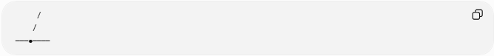
/
/
───●────

Complementary Angles
# Source: AI Source: Provided by: [Data Path: Persons Table -> ID Column: 1, Name_En Column: Motasem Essam] -> From: [ChatGPT] on [7/25/2026]
Two angles whose measures add to:
$${90}^{∘}$$
Example:
$${30}^{∘}+{60}^{∘}={90}^{∘}$$

Supplementary Angles
# Source: AI Source: Provided by: [Data Path: Persons Table -> ID Column: 1, Name_En Column: Motasem Essam] -> From: [ChatGPT] on [7/25/2026]
Two angles whose measures add to:
$${180}^{∘}$$
Example:
$${120}^{∘}+{60}^{∘}={180}^{∘}$$

Vertical Angles
# Source: AI Source: Provided by: [Data Path: Persons Table -> ID Column: 1, Name_En Column: Motasem Essam] -> From: [ChatGPT] on [7/25/2026]
Opposite angles formed by intersecting lines.
Properties:
- Have equal measures.
- Share the same vertex.

Corresponding Angles
# Source: AI Source: Provided by: [Data Path: Persons Table -> ID Column: 1, Name_En Column: Motasem Essam] -> From: [ChatGPT] on [7/25/2026]
Angles formed when a transversal crosses two parallel lines.

Alternate Interior Angles
# Source: AI Source: Provided by: [Data Path: Persons Table -> ID Column: 1, Name_En Column: Motasem Essam] -> From: [ChatGPT] on [7/25/2026]
Angles inside two parallel lines on opposite sides of a transversal.

Angle Relationships
Linear Pair
Two adjacent angles forming a straight line.
$$θ_{1}+θ_{2}={180}^{∘}$$

Around a Point
All angles around a point add to:
$${360}^{∘}$$

In a Triangle
The sum of interior angles:
$$A+B+C={180}^{∘}$$

In a Quadrilateral
The sum of interior angles:
$${360}^{∘}$$

Angle Measurement Tools
# Source: AI Source: Provided by: [Data Path: Persons Table -> ID Column: 1, Name_En Column: Motasem Essam] -> From: [ChatGPT] on [7/25/2026]
Angles are measured using:
Protractor
A tool used to measure angles in degrees.

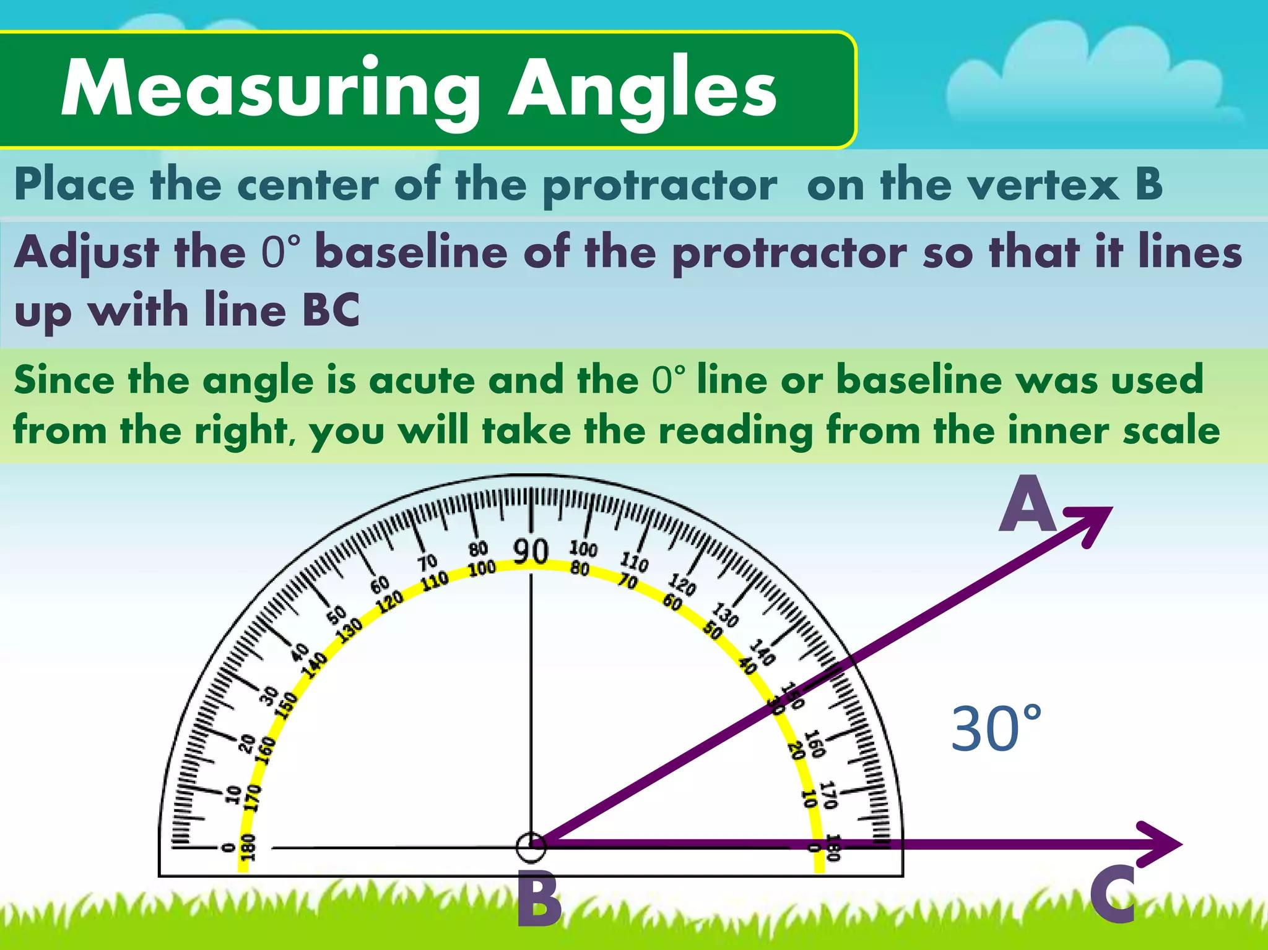
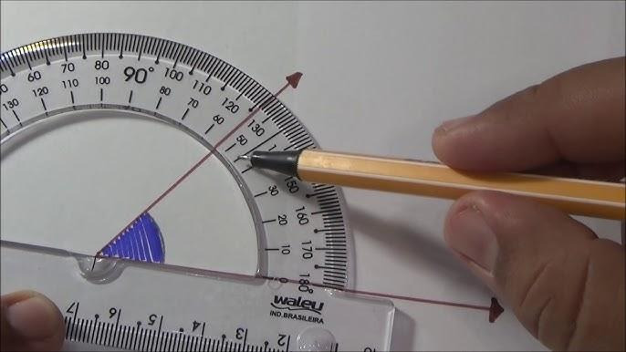
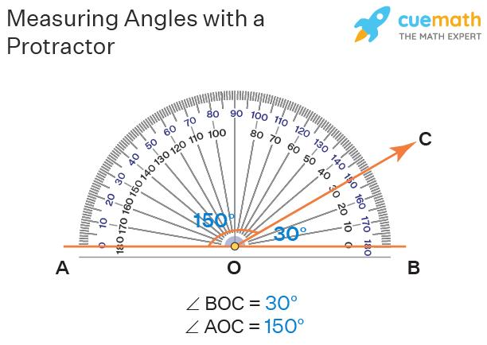


Real-World Examples
# Source: AI Source: Provided by: [Data Path: Persons Table -> ID Column: 1, Name_En Column: Motasem Essam] -> From: [ChatGPT] on [7/25/2026]
Angles appear in:
- Clock hands.
- Buildings.
- Bridges.
- Roads.
- Scissors.
- Doors.
- Machines.
- Robot joints.
- Computer graphics.
- Engineering drawings.

Applications
# Source: AI Source: Provided by: [Data Path: Persons Table -> ID Column: 1, Name_En Column: Motasem Essam] -> From: [ChatGPT] on [7/25/2026]
Angles are fundamental in:
- Plane Geometry
- Coordinate Geometry
- Trigonometry
- Engineering
- Architecture
- Construction
- Surveying
- CAD (Computer-Aided Design)
- Physics
- Robotics
- Computer Graphics

Properties of Angles
# Source: AI Source: Provided by: [Data Path: Persons Table -> ID Column: 1, Name_En Column: Motasem Essam] -> From: [ChatGPT] on [7/25/2026]
An angle:
- Has a vertex.
- Has two rays as sides.
- Has a measurable amount of rotation.
- Can be classified by size.
- Can be measured in degrees or radians.
- Can be positive or negative depending on rotation direction.

Comparison with Related Geometric Objects
# Source: AI Source: Provided by: [Data Path: Persons Table -> ID Column: 1, Name_En Column: Motasem Essam] -> From: [ChatGPT] on [7/25/2026]
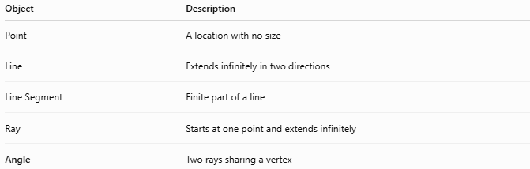
Object | Description
Point | A location with no size
Line | Extends infinitely in two directions
Line Segment | Finite part of a line
Ray | Starts at one point and extends infinitely
Angle | Two rays sharing a vertex

Key Points
# Source: AI Source: Provided by: [Data Path: Persons Table -> ID Column: 1, Name_En Column: Motasem Essam] -> From: [ChatGPT] on [7/25/2026]
- An Angle is formed by two rays sharing a common endpoint.
- The common endpoint is the vertex.
- The sides of an angle are rays.
- Angles measure rotation between two directions.
- Angles are measured in:
$$\text{degrees}\left(∘\right)$$
or
$$\text{radians}$$
- The main angle classifications are:
  - Acute
  - Right
  - Obtuse
  - Straight
  - Reflex
  - Complete

Conclusion
# Source: AI Source: Provided by: [Data Path: Persons Table -> ID Column: 1, Name_En Column: Motasem Essam] -> From: [ChatGPT] on [7/25/2026]
An Angle is one of the fundamental concepts of geometry. It describes the amount of rotation between two rays that meet at a common endpoint called the vertex. Angles are used to classify shapes, analyze relationships between lines, measure rotation, and describe direction. They are essential in plane geometry, coordinate geometry, trigonometry, engineering, architecture, construction, surveying, CAD, robotics, physics, and computer graphics, where accurate measurement and control of direction are required.

